Compute Service
Compute Services overview
Elastic Computing
Server-less Compute service
Deploying and scaling web applications

  - Compute Services overview
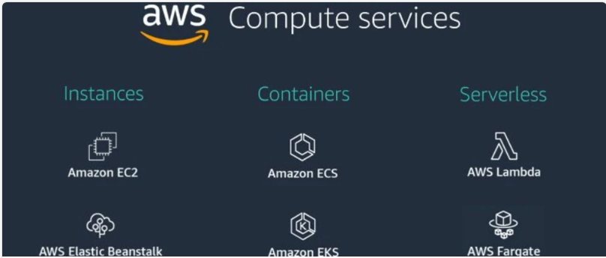

  - Elastic Computing

EC2 - Elastic Compute Cloud is one of the most popular and mostly used compute services that AWS provides for doing computations and processing. EC2 allows you to deploy virtual servers within your AWS environment. You can think of it as a virtual machine deployed on AWS physical data-centers irrespective of your local environment.
EC2 service can be broken down into following components.
Amazon Machine Images (AMI)
AMI's are Images or templates for preconfigured EC2 instances allow you to quickly launch Ec2 servers based on configuration
Instance Types
Once you select AMI's, you need to select what type of EC2 instance type you are required to use. AWS provides tons of options divided into Instance type families that offers distinct performance benefits. You can read further about these instances in details from here.
Instance Purchasing options
AWS also provides instance purchasing options for instances through a variety of different payment plans. They have been designed to help you save cost by selecting the most appropriate option for your deployment. You can read further about these instances in details from here.
User Data
During the launch of EC2 instance, there is an option available for which allows you to enter commands that will during the first boot cycle of the instance. This is a great way to automatically perform functions you want to to execute at your instance startup.
Storage
As a part of launching ec2 instance, you're asked to select configuration for storage. As storage is a crucial part for any server we have to provide some number in GB's for persisting the ec2 data.
Security
Security is fundamental part for any AWS deployment services. During launch of EC2, you're asked to create or attach a security group with your instance. A security group is essentially instance level firewall for managing inbound and outbound traffic for your EC2.
  - Server-less Compute service

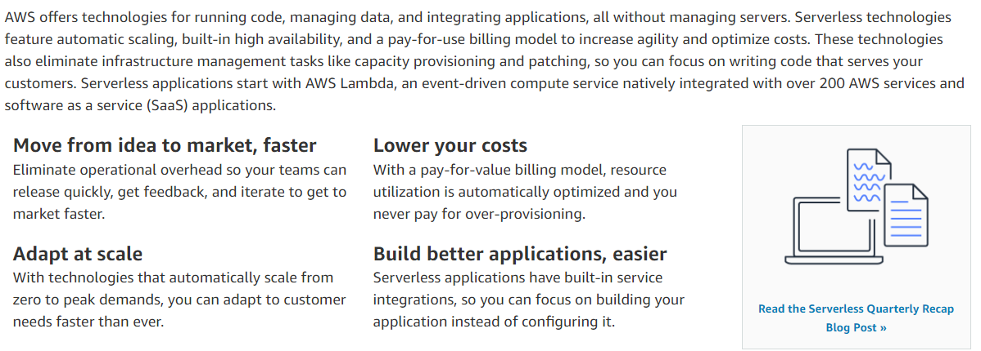

  - Deploying and scaling web applications

https://aws.amazon.com/blogs/architecture/scale-your-web-application-one-step-at-a-time/

Two Types of Scaling:

- Vertical Scaling :
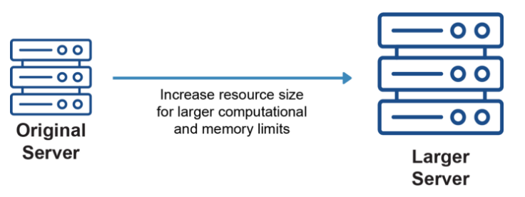

- Horizontal Scaling:

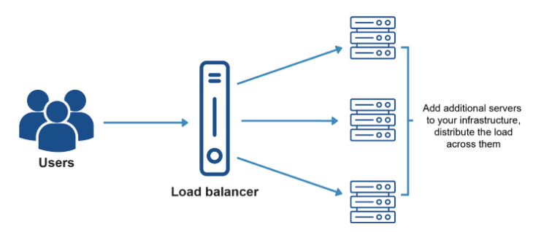

Deployment Steps:

Step 1: Ease server load.

Step 2: Reduce read load by adding more read replicas.

Step 3: Reduce write requests.

Step 4: Introduce a more robust caching engine.

Step 5: Scale your server.

